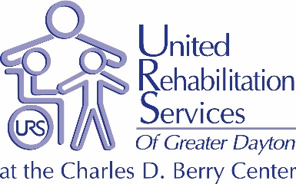

Career Opportunities Listing

For 65 years, United Rehabilitation Services (URS) has provided a comprehensive continuum of services to meet the needs of children, adults and seniors with developmental and acquired disabilities throughout the Greater Dayton Region.
URS has the region’s only fully inclusive Early Childhood Education Center serving typically developing children and those with special needs. On-site nurses and therapies are available to support the children and adults we serve throughout the day. As a CARF accredited organization and a 5 Star rated program under Ohio Step Up to Quality, URS offers the highest quality of care for all children and adults of all abilities.
URS’ wide-array of programs include: Adult Day Services, Vocational Training as part of the URS Academy, Infant, Toddler, Preschool and School-Age Programs. Our on-site Therapy Center offers outpatient services in Physical, Occupational, Speech and Augmentative Communications.
URS offers community-based Employment Services, including Transition Youth and Project Search Programs to six counties in SW Ohio.

Please visit our website at www.ursdayton.org for more details.

Development Department

Special Events & Communications Coordinator – Full-Time, Salaried Position

Duties: The Special Events and Communications Coordinator at URS is a leadership position that oversees and coordinates all Special Events; including budgets, sponsorships, and donations. Additional key functions include creating the Agency annual report, brochures, and marketing collateral, managing communications and regular updates to the Agency website and social media accounts, and maintaining the donor database in Blackbaud RaisersEdge.

Qualifications: A Bachelor’s Degree in Communications, Marketing or closely related field is required with three - five years’ experience in Development or Special Event planning and execution. Graphic design experience is a plus! Strong computer skills, self-motivation, and the ability to manage multiple priorities are a must. Excellent oral, written, electronic and interpersonal communication skills are also required to be successful in this role. Familiarity with job related software to include Blackbaud would be preferred. Ability to work a flexible schedule as the situation dictates is also a must (i.e., weekends, evenings, extended hours). Must maintain a valid Ohio driver’s license and follow Agency insurance carrier requirements.

POSITION PROVIDES COMPETITIVE PAY AND BENEFITS DEPENDENT UPON EDUCATION AND EXPERIENCE. POSITION WILL REMAIN POSTED FOR FOUR (4) WEEKS, OR UNTIL QUALIFIED APPLICANT IS DETERMINED.

TO APPLY FOR POSITIONS, SEND RESUME’ TO:
Human Resources YOU MAY ALSO SUBMIT YOUR RESUME’ AT:
United Rehabilitation Services www.nationjob.com or
4710 Old Troy Pike www.greaterdaytonworks.com
Dayton, OH 45424
FX: 937-236-8930
email: hr@ursdayton.org
Website: www.ursdayton.org

