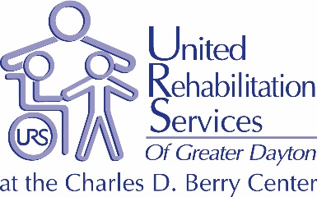

Career Opportunities Listing

For 65 years, United Rehabilitation Services (URS) has provided a comprehensive continuum of services to meet the needs of children, adults and seniors with developmental and acquired disabilities throughout the Greater Dayton Region.
URS has the region’s only fully inclusive Early Childhood Education Center serving typically developing children and those with special needs. On-site nurses and therapies are available to support the children and adults we serve throughout the day. As a CARF accredited organization and a 5 Star rated program under Ohio Step Up to Quality, URS offers the highest quality of care for all children and adults of all abilities.
URS’ wide-array of programs include: Adult Day Services, Vocational Training as part of the URS Academy, Infant, Toddler, Preschool and School-Age Programs. Our on-site Therapy Center offers outpatient services in Physical, Occupational, Speech and Augmentative Communications.
URS offers community-based Employment Services, including Transition Youth and Project Search Programs to six counties in SW Ohio.

Please visit our website at www.ursdayton.org for more details.

Development Department

Development Director – Full Time, Salaried

Duties: The Development Director at URS is a senior level position and oversees and coordinates all Development Department functions including executing comprehensive marketing plans for all programs, volunteer recruitment, special events, grant writing, planned giving, and other fundraising activities. Through a mix of media relations and promotion, public relations strategies, donor relations and community involvement, increase the community’s awareness and understanding of United Rehabilitation Services, its programs and its Mission. The position is also the direct Supervisor of the Volunteer and Special Events staff.
Qualifications: Bachelor’s Degree in communications or closely related field is required with ten years’ experience in Development with strong skills in written and oral communications. Prior supervisory or management experience is preferred and the ability to manage multiple priorities is a must. Strong computer skills and familiarity with job related software is preferred.

Salary Range - $67,000-$97,000

POSITION PROVIDES COMPETITIVE PAY AND BENEFITS DEPENDENT UPON EDUCATION AND EXPERIENCE.

TO APPLY FOR POSITIONS, SEND RESUME’ TO:
Human Resources YOU MAY ALSO SUBMIT YOUR RESUME’ AT:
United Rehabilitation Services www.nationjob.com or
4710 Old Troy Pike www.greaterdaytonworks.com
Dayton, OH 45424
FX: 937-236-8930
email: hr@ursdayton.org
Website: www.ursdayton.org

